**Resume Builder**

**resumebuild.herokuapp.com**

Elaboration2 Document

**Submitted to**:

Prof. Francis T. Marchese

**Submitted by:**

Dhruvil Gandhi

Jacky Patel

Shraddha Thakkar

|  |  |  |  |
| --- | --- | --- | --- |
| **Date** | **Version** | **Author** | **Summary of Changes Made** |
| 4/5/2015 | 1.0 | Dhruvil Gandhi  Jacky Patel  Shraddha Thakkar | Document Creation |
| 4/7/2015 | 1.0 | Dhruvil Gandhi | Minor Edit |
| 5/11/2015 | 2.0 | Dhruvil Gandhi  Jacky Patel  Shraddha Thakkar | Version 2 Addition |

**Table of Contents**

|  |  |  |
| --- | --- | --- |
| 1. | Introduction | 3 |
|  | 1.1 About Resume Builder | 3 |
| 2. | Domain Model | 4 |
| 3. | Design Model | 5 |
|  | 3.1 Design Class Diagram | 5 |
| 4. | Sequence Diagram | 6 |
|  | 4.1 | 6 |
|  | 4.2 | 7 |
|  | 4.3 | 8 |
| 5. | Test Model | 9 |
| 6. | Use – Case Storyboards and UI Prototypes | 10 |
|  | 6.1 Use Cases | 10 |
|  | 6.2 Use-case Storyboards | 11 |
|  | 6.2.1. Home Screen of Application | 11 |
|  | 6.2.2. Resume Generation | 12 |
|  | 6.2.3. sample Output | 13 |
|  | 6.2.4. Report Error | 14 |
|  | 6.2.5. Contact | 16 |
|  | 6.2.6. View FAQ | 17 |
|  | 6.2.7. Menu Bar for Application | 18 |
| 7. | Software Architecture Details | 19 |
| 8. | Implementation Model | 20 |
| 9.  10. | Sample Output  Previous Release vs Next Release | 21  24 |
|  |  |  |

1. **Introduction**

This document provides an overview of Elaboration 2 of our project, which is an independent python application to generate resume in word, pdf and webpage format. It is intended for undergraduates and graduates who want to create their resume in standard format and want a basic portfolio page of their resume. This concept was derived from Career Services department where it is required that a student gets his resume approved after numerous attempts.

1. **Domain Model**

The domain model for resume builder is as shown below:

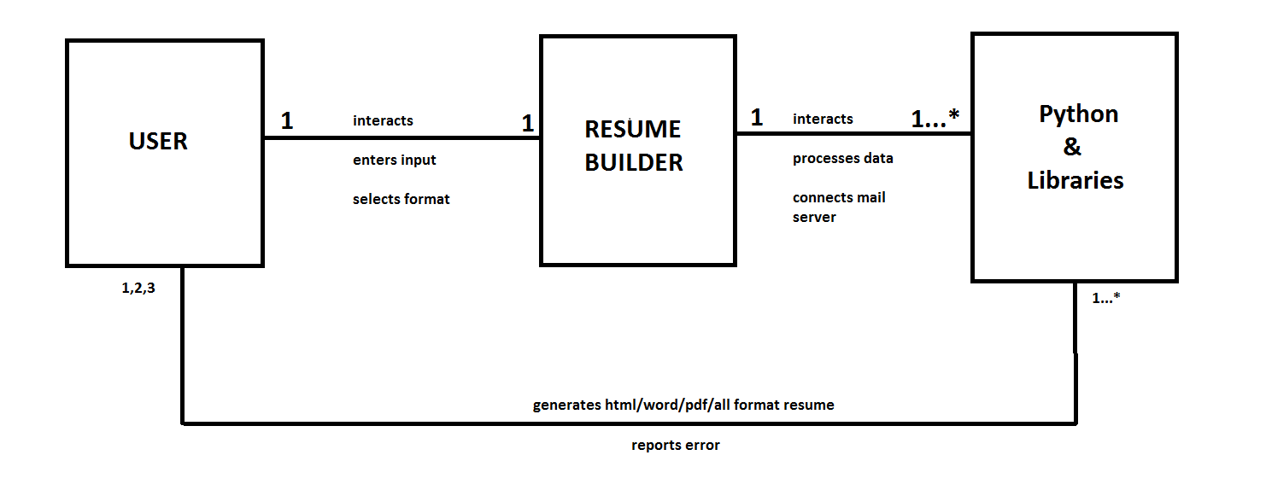

1. **Design model**

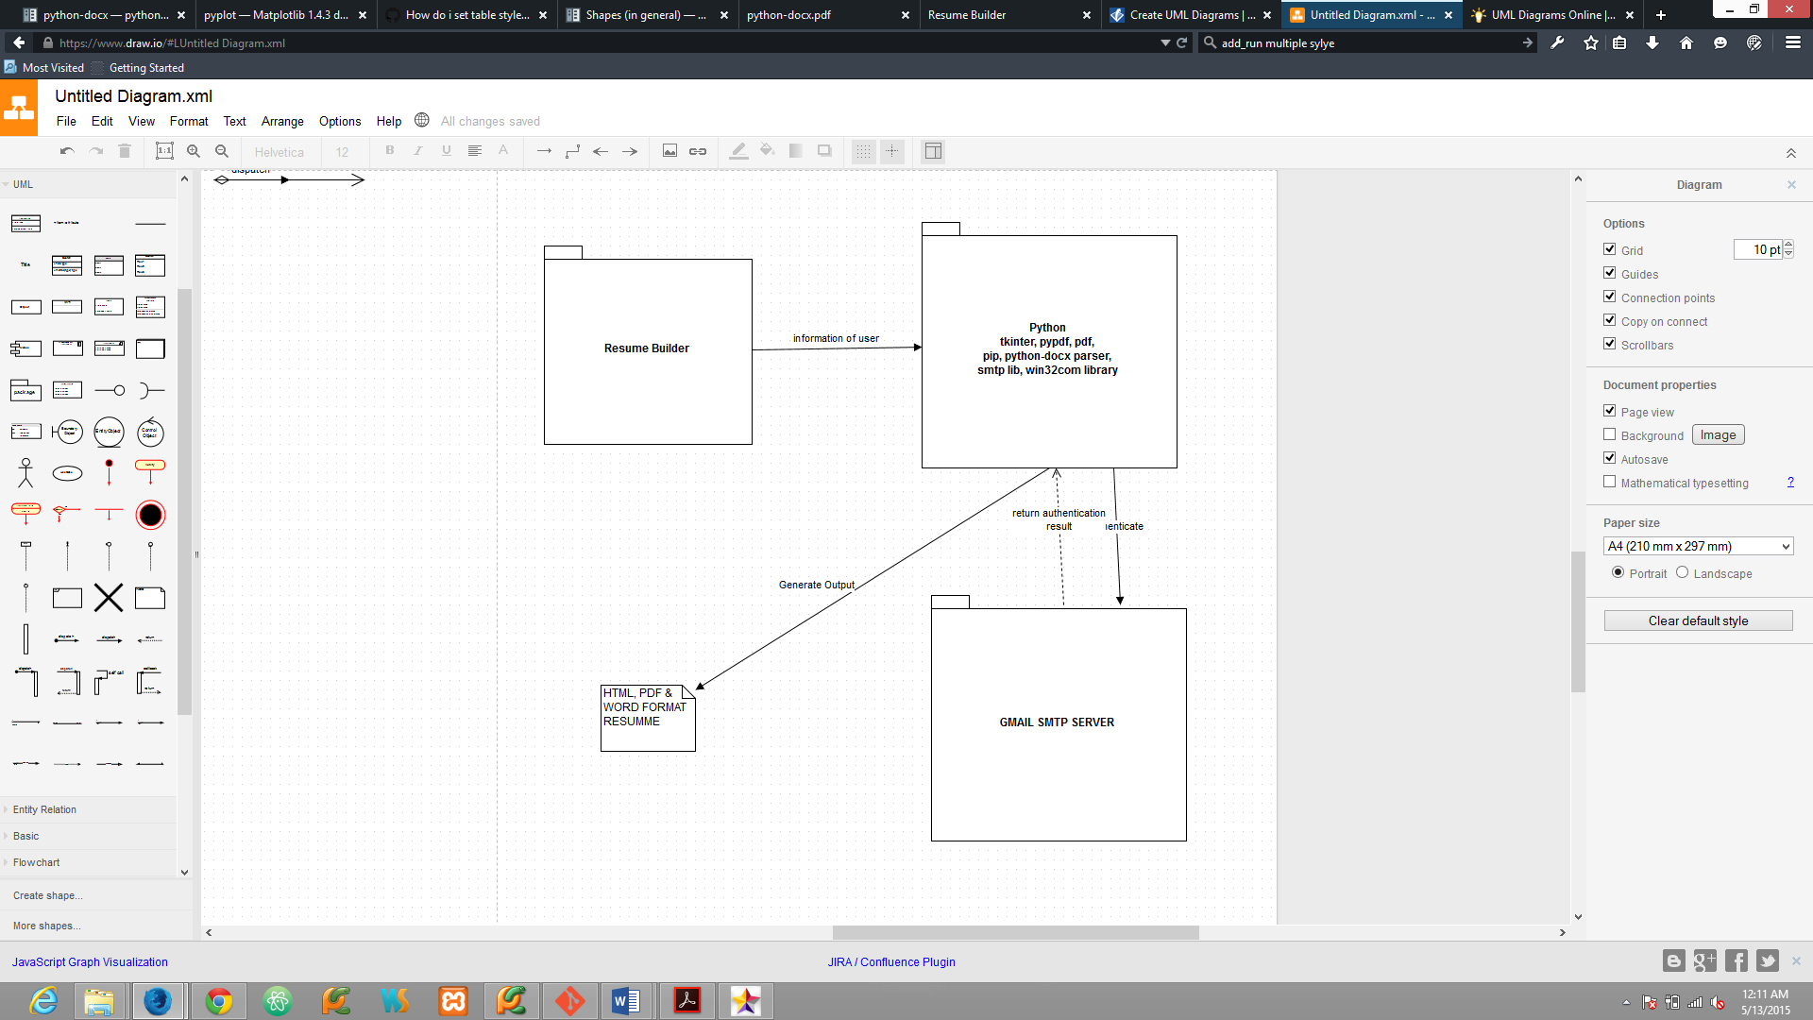

**Package Model**

1. **Sequence Diagrams**

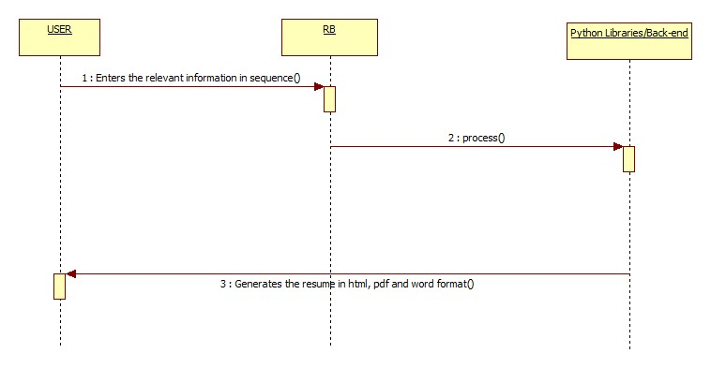

Figure 1 Html resume generation

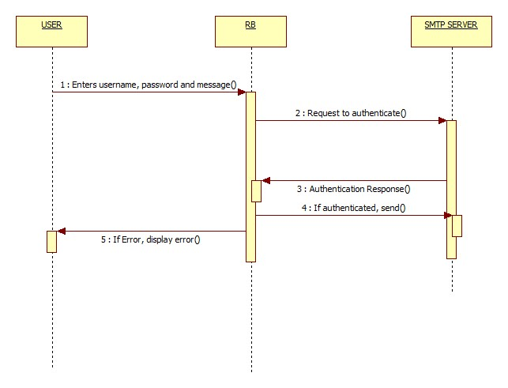

Figure 2 Contact

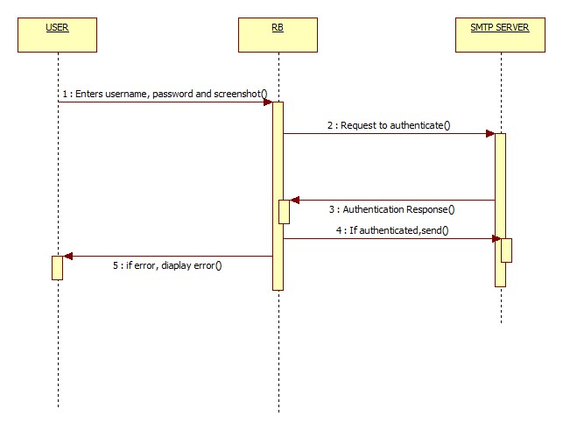

Figure 3 Report Error

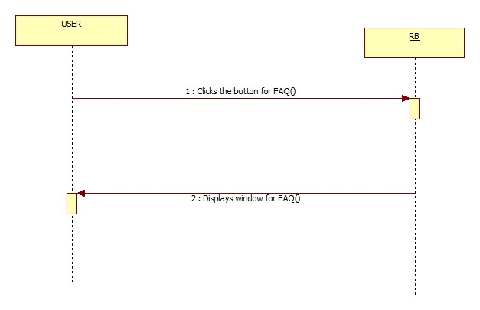

Figure 4 View FAQ

1. **Test Model**

Black box testing and white box testing will be used to test the overall correctness of the application. In black box testing the user will follow different steps to check all the paths of the application including different functional complexities. The user will execute following steps:

1. User starts the application.
2. User wants to contact developer
   * 1. User uses his Gmail login info
     2. User writes a message and sends the message to the developer
3. User wants to send error to the developer
   * 1. User uses his Gmail login info
     2. User selects screenshot file and sends it to the developer
4. User view FAQ.
5. User wants to create resume, starts main screen and fills out appropriate details and generates resume
6. User checks for update
7. User wants to visit product site

White box testing will be done by the developers.

1. **Use-Case Storyboards and UI Prototypes**
   1. **Use Case**

Elaboration 1 consists primarily of Use Case 1 (Contact Developer), Use Case 2(UC2: Report Error), Use Case 3 (UC3: FAQ) and Use Case 4 (UC4: Generate Webpage Resume). These cases represents the basic GUI and html page generation of the system.

Other features such as protecting user for Gmail, proper error reporting, word and pdf generation and other fields of the resume will be included in Elaboration 2: Release Version 2.

**Use Case UC1: Contact Developer**

|  |  |
| --- | --- |
| **Use Case** | **UC1: Contact Developer** |
| **Description** | **User sends a message to developer** |
| **Primary Actor** | **User** |
| **Precondition** | **User has internet connection** |
| **Post Condition** | **Mail is sent to the developer** |
| **Main Success Scenario** | **User successfully send mail to the developer** |
| **Alternative flow** | **User enters wrong password or authentication is blocked by Gmail smtp server as the application unknown for server** |

**Use Case UC2: Report Error**

|  |  |
| --- | --- |
| **Use Case** | **UC2: Report Error** |
| **Description** | **User send error to the developer** |
| **Primary Actor** | **User** |
| **Precondition** | **Error in the application and user takes a screenshot.**  **User has active internet connection** |
| **Post Condition** | **User emails screenshot to the developer** |
| **Main Success Scenario** | **User emails screenshot to the developer** |
| **Alternative flow** | **User enters wrong password or authentication is rejected by Gmail server.** |

**Use Case UC3: FAQ**

|  |  |
| --- | --- |
| **Use Case** | **UC3: FAQ** |
| **Description** | **User wants to view FAQ for the application** |
| **Primary Actor** | **User** |
| **Precondition** | **None** |
| **Post Condition** | **None** |
| **Main Success Scenario** | **User views FAQs** |
| **Alternative flow** | **None** |

**Use Case UC4: Create RESUME**

|  |  |
| --- | --- |
| **Use Case** | **UC4: Create RESUME** |
| **Description** | **User wants HTML/PDF/WORD page of his resume** |
| **Primary Actor** | **User** |
| **Precondition** | **None** |
| **Post Condition** | **Resume in HTML/PDF/WORD format generated** |
| **Main Success Scenario** | **HTML/WORD/PDF page is generated** |
| **Alternative flow** | **None** |

**6.2 Use-Case Story Board**

**6.2.1 Home Screen of Application**

This the landing screen of the application when user starts the application.

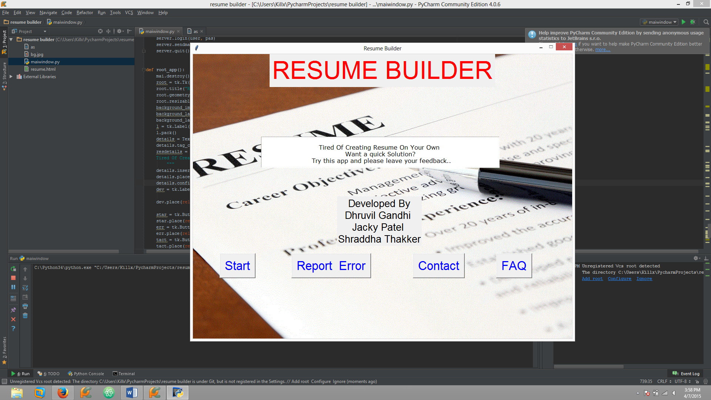

**6.2.2 Resume Generation**

This will be displayed when user clicks on Start and the fields.

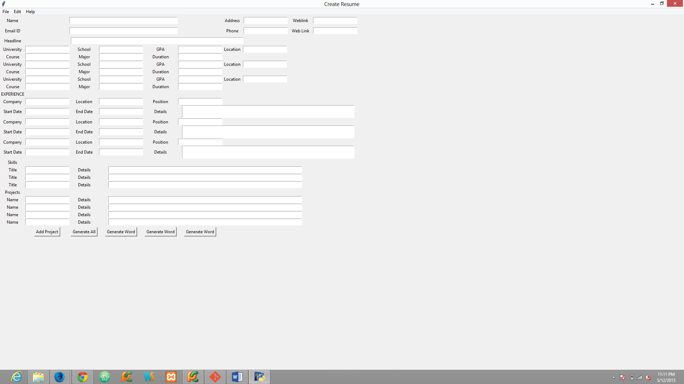

**6.2.3 Output Confirmation**

The follwoing screen will be displayed when the user clicks generate option:

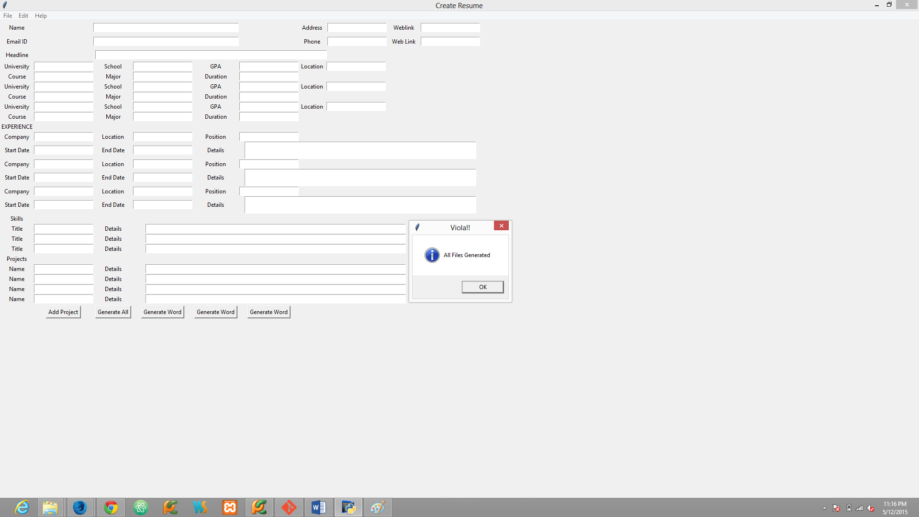

**6.2.4 Report Error**

When user clicks on Report Error this dialog will be generated.

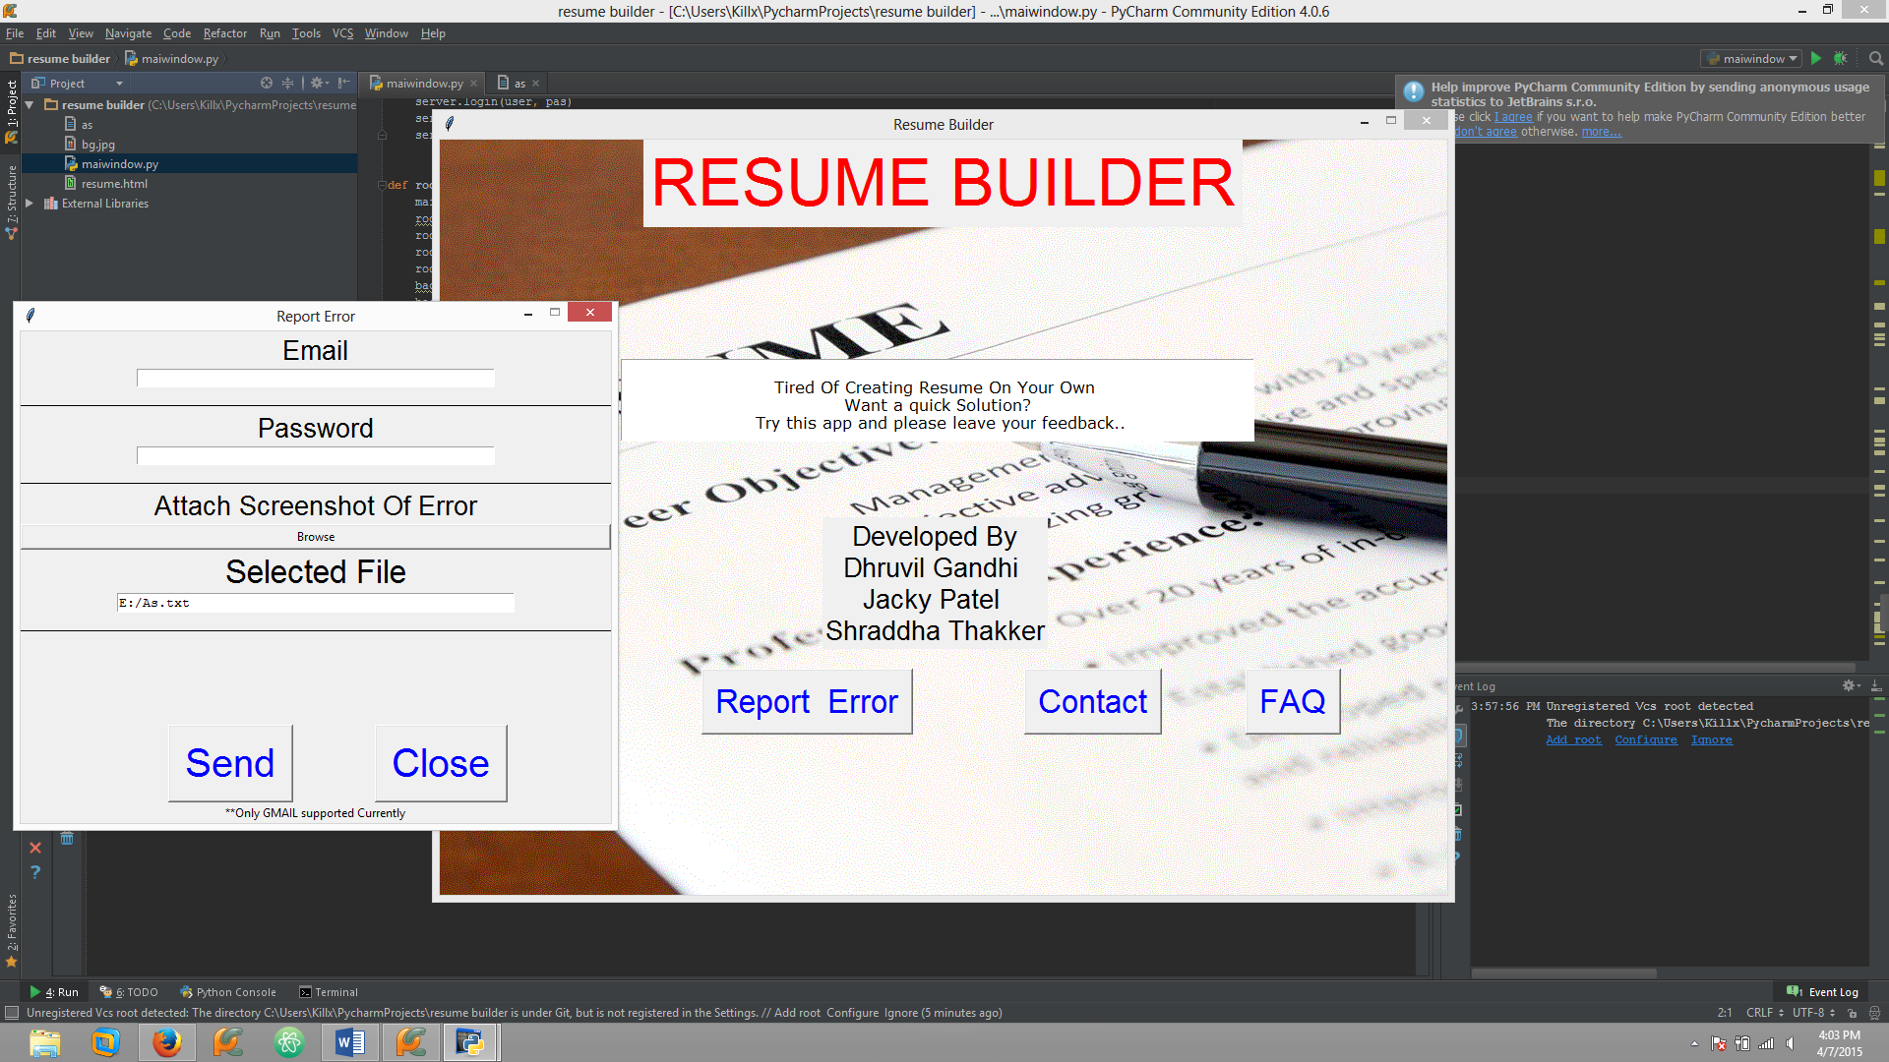

**6.2.5 Contact**

When user clicks on contact, this dialog will pop-up

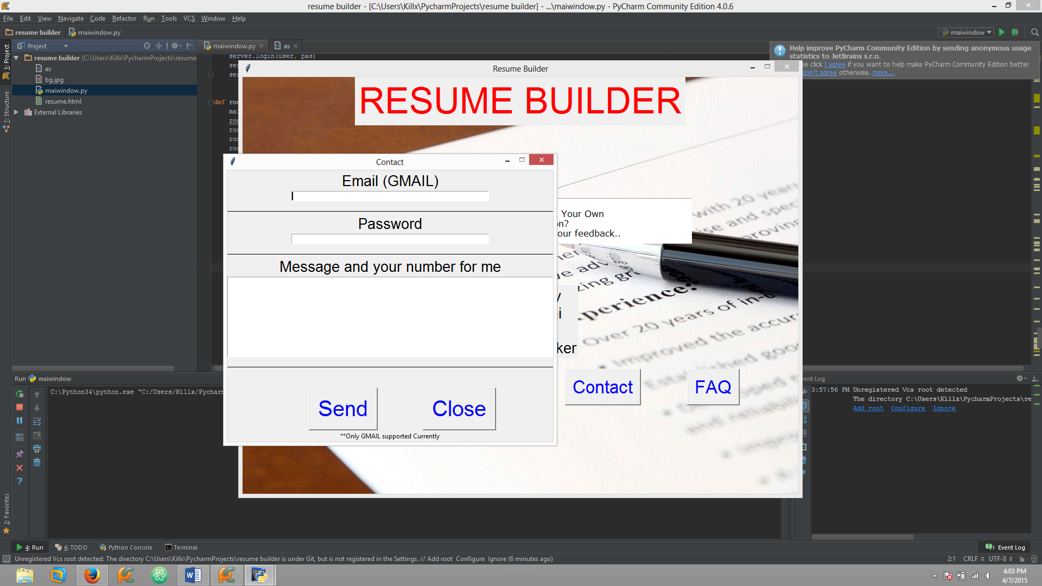

**6.2.6 View FAQ**

When user clicks on FAQ or from the menu bar in application, following window will be presented.

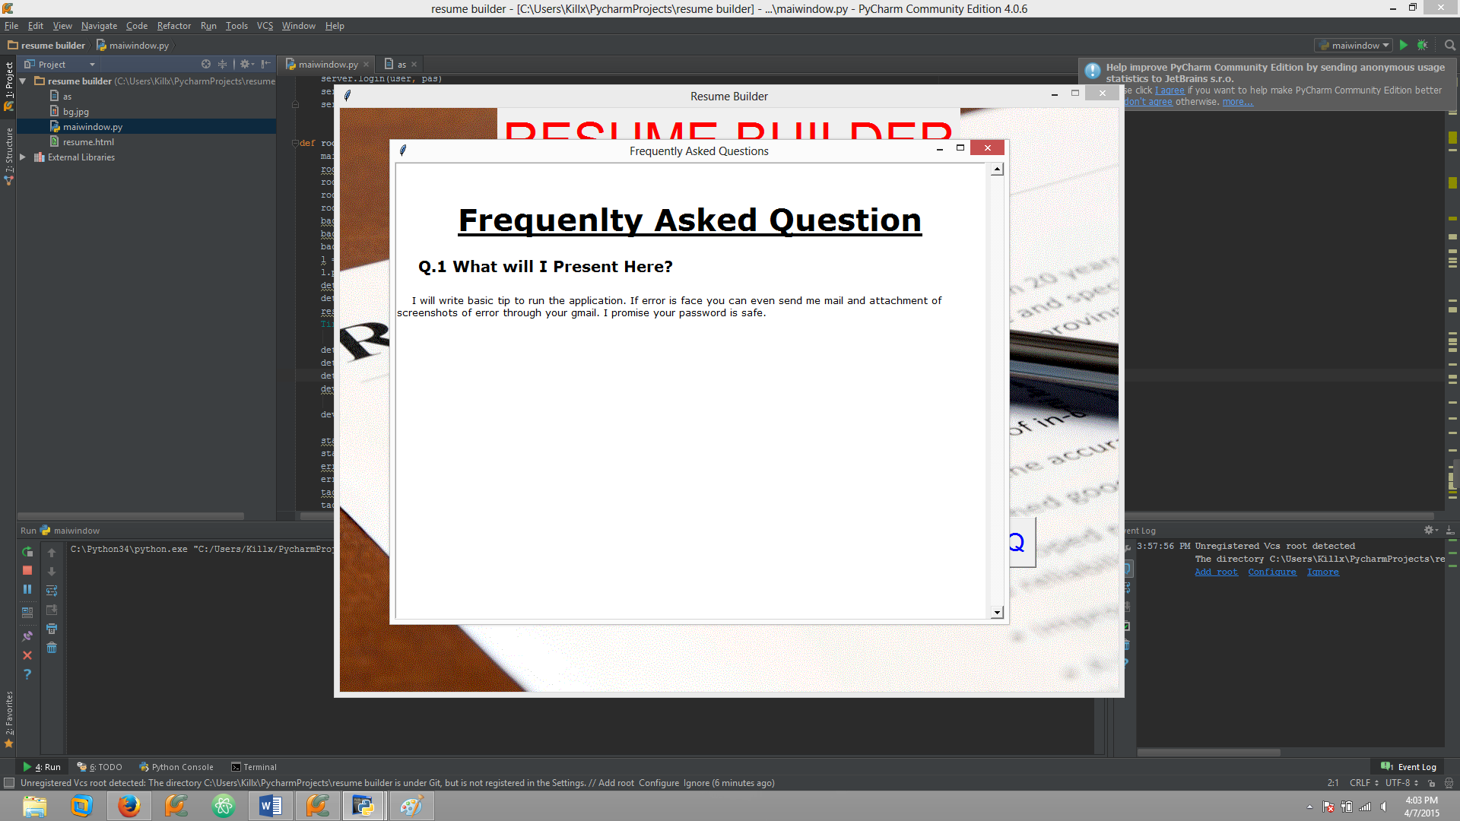

**6.2.7 Menu Bar for Application**

Menu-bar for the application.

When user clicks on check for update or About, he will be redirected to the application’s website: [resumebuild.herokuapp.com](http://resumebuild.herokuapp.com/)

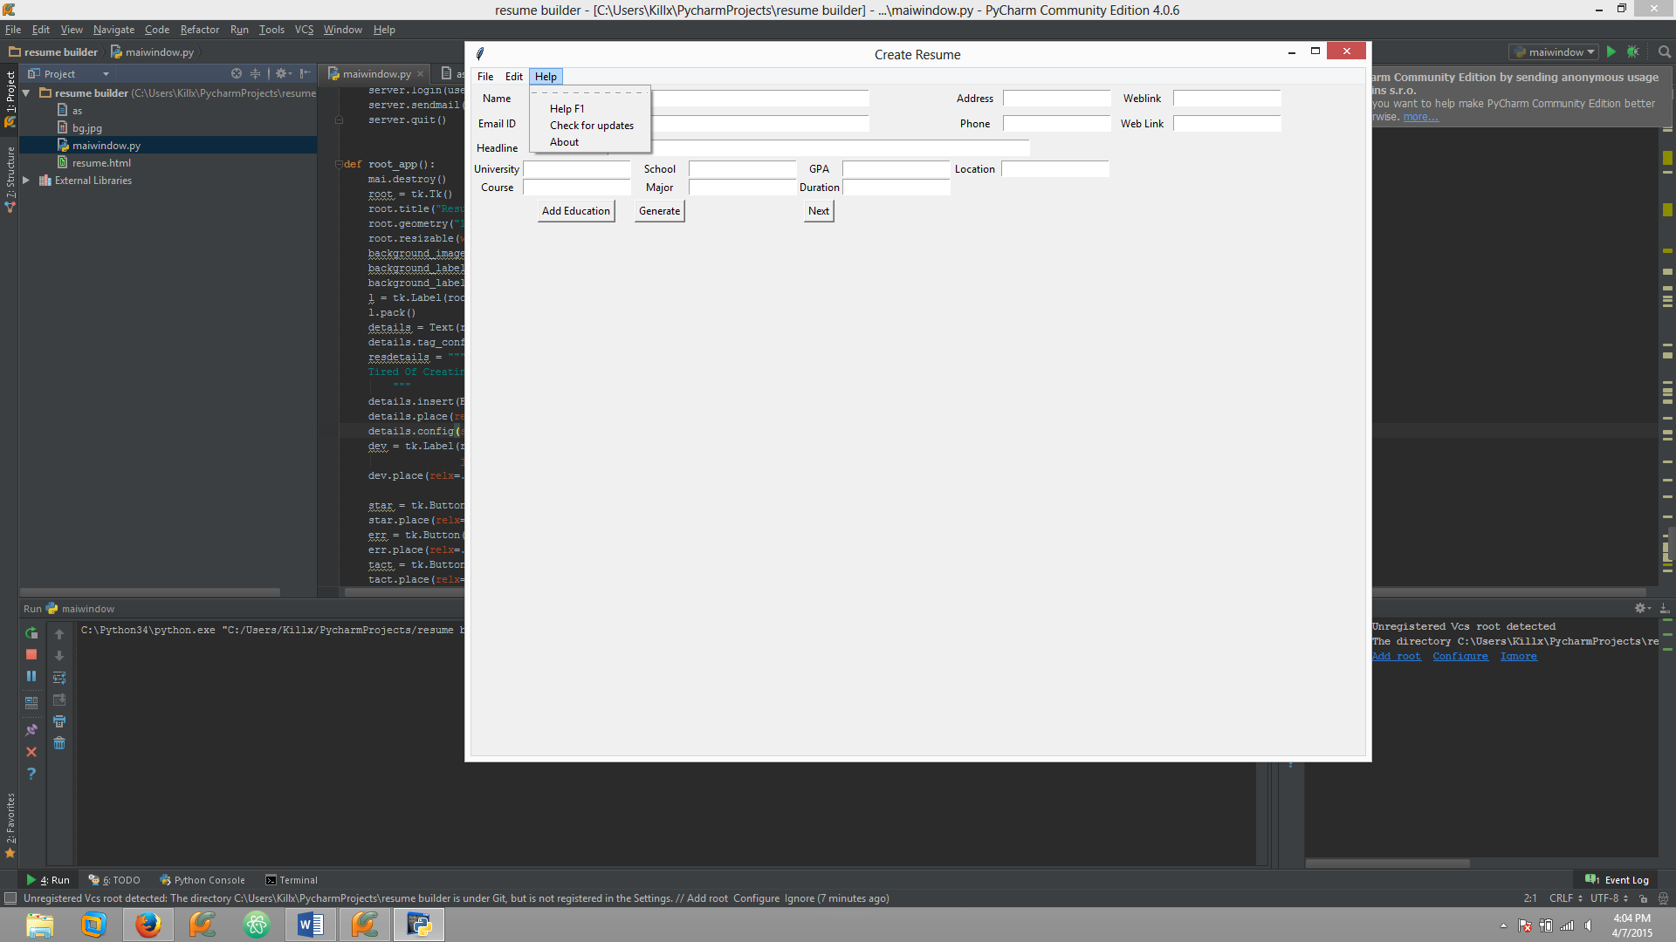

1. **Software Architecture**

The application was designed using python and its tkinter library for GUI. Many libraries of python are tkinter, win32com, webbrowser, smtplib, docx and its various components, pypdf and pdf. pip package manager is used to back up these libraries and their dependencies.

The main architectural issue faced during requirement phase and design phase was which language to use to develop the required application as it requires interaction with Gmail/ other mail servers, MS office word and pdf format documents. After researching, we found the appropriate libraries which interacted with the required objects appropriately and provided many features which were of use to this application. There were many errors in the pdf and generic and utils python library for python 3.4. I changed the library and updated it.

The architecture is built using libraries specified above.

1. **Implementation Model**

This application is created under GPL license.

It is hosted on Github. Its source code can be found [here](https://github.com/dhruv857/resumebuilder).

The main file for this application is **maiwindow.py**.

We are also creating a webpage for the application [here](http://resumebuild.herokuapp.com/).

1. **Sample Output**

These are the output files generated after the user fills out and selects to generate all files:

HTML RESUME

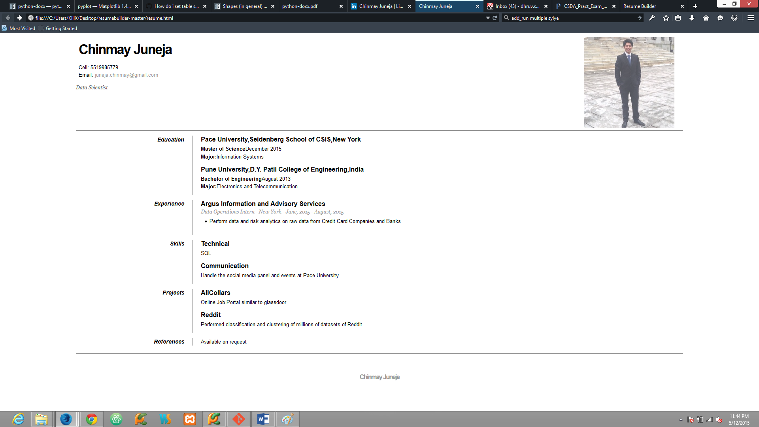

WORD FORMAT

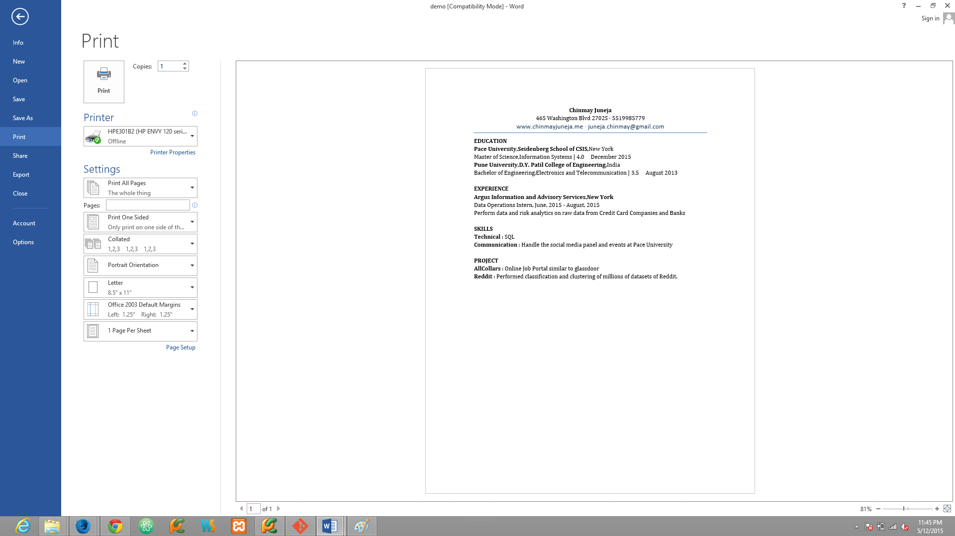

PDF FORMAT

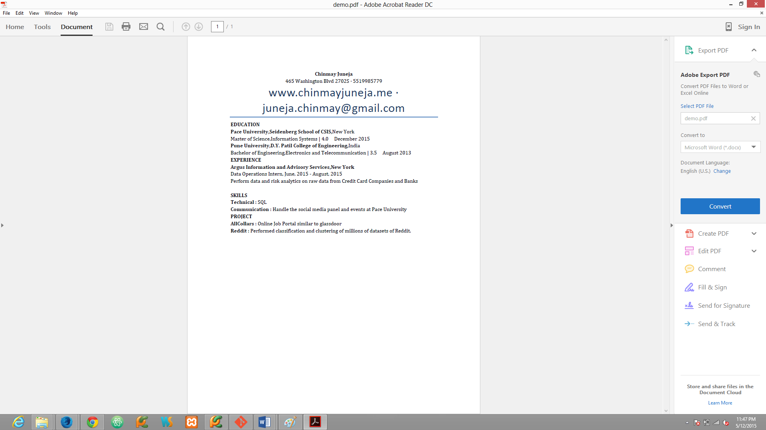

1. **Next Release Plans**

Features planned during during first release that are incorporated in this release:

* All field for resume
* Word format generation
* PDF format generation
* Improved UI
* Minor Fixes

We are planning to include following features in future:

* Multiple mail login
* Data save feature
* Error handling with automatic report generation
* Tips on start of application